UNIVERSITY OF LONDON
GOLDSMITHS COLLEGE

B.Sc. Examination 2020

COMPUTING AND INFORMATION SYSTEMS

IS53002B Neural Networks

Duration: 2 hours 15 minutes

Date and time:

This paper is in two parts: part A and part B. You should answer ALL
questions from part A and TWO questions from part B. Part A carries
40 marks, and each question from part B carries 30 marks. The marks
for each part of a question are indicated at the end of the part in
[.] brackets.

Electronic calculators must not be programmed prior to the examination. Calculators which display graphics, text or algebraic equations are not allowed.

THIS PAPER MUST NOT BE REMOVED FROM THE EXAMINATION ROOM

Part A. Question 1.

a) What are the main differences between feedforward and recurrent neural
networks with respect to their connectivity? Explain these differences briefly. [6]
Feedforward Neural Networks (FNNs) have a strictly one-way connectivity: signals flow from the input layer, through hidden layers, to the output layer. The graph is acyclic, meaning there are no feedback loops, so each input is processed independently without reference to previous inputs. As a result, FNNs are memoryless and best suited to static input–output mappings such as image classification.
Recurrent Neural Networks (RNNs), in contrast, include feedback connections from the hidden layer back to itself or to earlier layers. This creates cycles in the network, allowing the output of one step to influence the next step through a persistent hidden state. Because of this recurrent connectivity, RNNs have a form of memory, making them suitable for modeling temporal and sequential data such as speech, text, and time series.
In summary, FNNs are feed-forward, acyclic, and memoryless, while RNNs are recurrent, cyclic, and stateful, enabling learning of dependencies across time.

b) Explain briefly how the overall solution is decided in static neural network
committees. Give the two methods for building such static network committees. [6]
A static committee machine combines the outputs of several independently trained neural networks in order to improve performance. The term static means that once the networks are trained, their parameters remain fixed, and the combination is simply a function of their outputs.
Overall solution:
The solution is typically obtained by averaging the outputs of the networks (for regression) or by majority voting (for classification). This ensemble approach reduces variance and provides a more reliable generalization than any individual network.
Two main methods for constructing static committees (Haykin):
- Different initial conditions – Several networks of the same architecture are trained on the same dataset but with different random weight initializations. Because training may converge to different local minima, the resulting diversity improves the committee’s performance.
- Different training subsets – Each network is trained on a different subset of the training data (e.g., bootstrapped samples). This decorrelates the errors among networks, leading to stronger ensemble performance.

c) A single-layer Perceptron with 2 inputs x₁, x₂ and 2 corresponding weights
w₁= 0.1, and w₂= –0.15 is given. Compute the output of this Perceptron network
given the input vector: x₁= –0.5, x₂=0.5, in each of the following two cases: [8]

- using a sigmoidal activation function;
- using the threshold activation function.

d) Write down the training rule for single-layer thresholded Perceptron networks.
Explain each term in this training rule. [6]

e) Consider a Multilayer Perceptron (MLP) neural network with 2 hidden nodes
and 1 output node be given. There are two inputs to the network ( x₁, x₂ ), and
seven weights ( w₁, w₂, w₃, w₄, w₅, w₆, w₇ ) as shown in the figure below. All of
the nodes φ₁, φ₂ and φ₃ use sigmoidal activation functions.
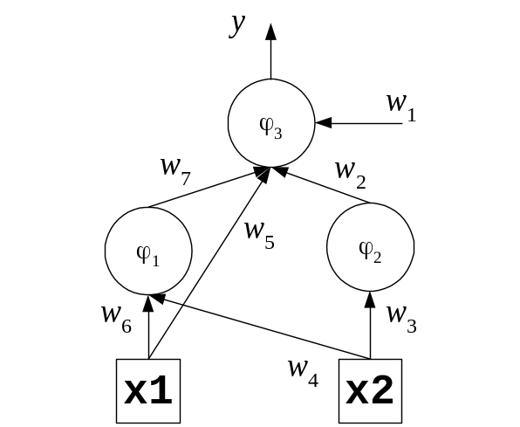

Give the equations for calculating the node outputs during the forward pass, and
for updating weights w₅ and w₇ during the backward pass. Use the notation for the
weights, inputs and node outputs given in the figure. [14]

IS53002B 2020 TURN OVER
Part B. Question 2.

a) Consider a single-layer sigmoidal Perceptron neural network with 3 inputs
and no threshold (i.e. without bias). Train this sigmoidal Perceptron with the
following examples in the given order assuming learning rate η=0.1.
x₁ | x₂ | x₃ | y
–0.2 | 0.15 | 0.1 | 0
–0.1 | 0.2 | 0.15 | 1

Show one training epoch using the batch gradient descent learning rule.
Begin with initial weights: ( w₁, w₂, w₃ )=( 0.1, –0.1, 0.15 ). [24]

b) Develop a single-layer Perceptron network with 3 binary inputs and a bias term
with input x₀ =0. This Perceptron should produce output y =1 only when most of
the inputs are one, that is when the inputs with values x_{i} =1 are more than these
with values x_{i} =0 (where: 1<=i<=3). Assume the following thresholding function:
f(x)=1 if s>=2 and 0 otherwise. Select proper integer values weights and draw
the architecture of the network. [6]

IS53002B 2020 TURN OVER

Part B. Question 3.

a) Describe which operations are performed in the storage phase of Hopfield
neural networks, and how the training rule is applied. [8]

b) Consider a Hopfield recurrent network with 3 neurons and 3 inputs: x₁, x₂ and x₃.
The initial weights are given by the following matrix:

0 0.1 –0.2
W = 0.1 0 –0.15
–0.2 –0.15 0
i) Give the formula for computing the neuron output in Hopfield networks. [6]

ii) Compute the outputs of the neurons in the given Hopfield network for
the state [0,1,1], and determine whether this is a stable or unstable
state for this network. [8]

iii) If the network is unstable for state [0,1,1], retrain the weights of the neuron
producing wrong output. [8]

IS53002B 2020 TURN OVER
Part B. Question 4.

a) Describe briefly the operations performed in each layer of the architecture of
self-organizing Kohonen neural networks. [6]

b) Give the formula for computing the distance between the weight vector and the
training input example used for unsupervised learning with Kohonen networks. [6]

c) A self-organizing Kohonen neural network with 2 neurons and 3 inputs feeding
each neuron is given. The initial weight vectors are: w₁ = ( –0.1, 0.2, 0.3 ), and
w₂ = ( 0.3, 0.2, –0.1 ). Consider the following input vector: x = ( 0.1, –0.15, 0.2 ).
i) Compute the outputs from the two neurons in this Kohonen network. [4]
ii) Briefly explain how the winning neuron is identified, and determine the index
of the winning neuron. [5]

iii) Demonstrate training of the weights of the winning neuron using the training
rule for Kohonen networks using learning rate η=0.1, and neighbourhood
parameter h=1.0. [9]

IS53002B 2020 END OF EXAMINATION

